Specification of second hand machinery for sale
№ | Specification
 | MACHINES FOR PLASTIC
1 | CNC 3D printer for plastic Stratasys Fortus 900mc (USA)  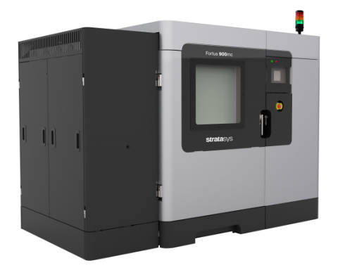  CNC 3D Printer for production of prototypes and small series of different types of plastic, silicone and rubber elements. The 3D printer allows the production of details with extreme complexity directly from the 3D computer models.  (1) 3D printer  Brand: Stratasys  Model: FORTUS 900mc  (2) Computer Numerical Control (CNC):  Brand: Touchworks  Technical specifications:  - Details up to 200 kg.  - Precision 0.089 mm  - Can work with many types of materials such as silicones, engineering plastics, rubber, etc.  - 95% rate of yield  - Total Installed Capacity: 7,5 kW  - Working volume (XYZ):  - 914.4 x 609.6 x 914.4 mm;  - The table supports 2 printing areas for small and large details;  - Material:  - Two vials for main material 1508 cc;  - Two vials for fixing material 1508 cc;  - Automatic switching from one vial to another;  - Dimensions: 2772 x 1683 x 2027 mm  - Reachable Accuracy:  - +/- .089 mm or +/- .0015 mm  - + Accuracy is highly dependent on geometric form. Accuracy data were selected statistically with 95% geometric accuracy.  - Network connection: 10/100 base T. Ethernet protocol.  - Operator Attendance: Minimum servicing only when starting and stopping the machine.  - Operating Environment: Maximum temperature in the working room 29°C. Maximum relative humidity 80%  - Power: 3х230 VAC, 50/60Hz, 40A  - Additional requirements: Compressed air, 6 Bar  - Certification: СЕ  - Software: Insight™ and Control Center™ job processing and management software.
2 | Automatic injection molding machine for plastic elements Haifly TX-1400 (China)  (1) Injection molding machine  Brand: Haifly  Model: TX-1400  (2) Computer Numerical Control (CNC):  Brand: Keba  Technical specifications:  - Machine base with square reinforced profile  - 4 Movable safety doors  - Removable hydraulic tank for easy cleaning and maintenance  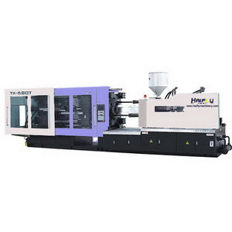  - Ceramic Heaters  - Infinitely variable auger rotation: 90 r/min  - Clamping force: 14 000 kN  - Opening stroke: 1350 mm  - Column spacing: 1310 × 1300 mm  - Thickness of the shape: 600-1400 mm  - Injection Strength: 360 kN  - System pressure: 16 Mpa  - Power: 141 kW  - Dimensions: 15.2×3.00×4.13 m  - Weight: 90 ton
 | METAL PROCESSING MACHINES
3 | 4-column Hydraulic Press TF AnHui Y32-400T (China)  (1) 4-column Hydraulic Press  Brand: TF AnHui  Model: Y32-400T  (2) Computer Numerical Control (CNC):  Brand: Omron  Model: NB7W-TW00B  Technical specifications:  - PLC Mitsubishi  - Automation and electrical equipment SIEMENS  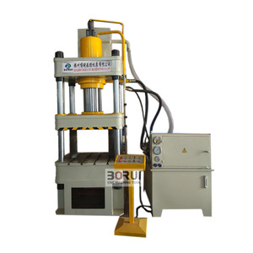  - Hydraulic pump 25YCY14-1B  - Valves: TAIFENG  - Seals: PARKER  - Compression: 4000 kN  - Ejection: 630 kN  - Return Strength: 500 kN  - Stroke: 800 mm  - Dispensing Stroke: 300 mm  - Maximum light aperture: 1250 mm  - Speed in progress:  - Free lift: 100 mm  - Under pressure: 4-10 mm  - Return: 70 mm  • Speed of dispensing:  - Dispensing: 55 mm  - Return: 145  - Substrate:  - LR: 1250 mm  - FB: 1250 mm  - External Dimensions:  - LR: 3500 mm  - FB: 1600 mm  - Above the floor: 4850 mm  - Power (main engine): 22 kW
4 | CNC Arch Hall Building Machine TF SUBM1000-55 (China)  (1) Arch Hall Building Machine  Brand: TF  Model: SUBM1000-55  (2) Computer Numerical Control (CNC):  Brand: Omron  Technical specifications:  - Simultaneous bending under arch and corruturing of sheet metal from 0.8 to 1.5 mm thickness  - Arches with complex shape and straight sections  - Arch length up to 40 m  - Bending speed up to 15 meters per minute  - Mobile Platform  - Overall dimensions LxWxH: 12000x2000x2300 mm  - Power supply: 3x380V @ 50Hz  - Finishing width of the sheet: 55%  - Sheet length: 10-40 m  - Weight: 15 ton  - Power: 50 kW  - Rollers Material: Steel 45, steel 60, HRC 58-62 2.3  - Shaft Material: Steel 45, HRC 58-62  - Material of the Knife: steel Cr12 1 Mo  - Plate material: Stainless steel 304L  - Roller steps: 14 pcs  - Bending Speed: Straight sheet: 15, Arch: 10: Crimp: 6 m/min  - Sheet width: 1000 mm  - Effective Width: 550 mm  - Sheet Thickness: 0.8-1.5 mm  - Controller and CNC: Omron PLC/CNC  - Suspension: 3 axes, 8 wheels
5 | CNC Laser Cutting Machine TF Wuxi laser QY-LCF1530 (China)  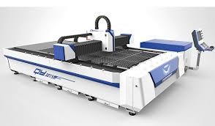  Brand: TF Wuxi laser  Model: QY-LCF1530  Technical specifications:  - Movement of waves through optical fibers 0.5 to 2W electricity of the  - Cutting speed up to 10 m/min  - Almost zero service  - Smooth cutting surface  - Laser Power Max: 500 W  - Maximum wavelength: 1064 nm  - Thickness of cutting: ≤ 12 mm  - Maximum running speed: 50 m/min  - Maximum width of the allotted: 0.15 mm  - Precision X-Y axis: ± 0.05 mm/m  - Accuracy with repeat X-Y axis: ± 0.02 mm  - Frequency: 1-500 Hz  - Cutting Surface: 1500 × 3000 mm  - Control system: CNC Digital Control system  - Positioning System: Infrared  - Total Installed Capacity: 6 kW  - Power supply: 380V/50Hz/60Hz/60Hz  - Cooling: Water  - Overall dimensions of the table: 4500x2600x1425 mm  - Overall dimensions of the cooling system: 1320x810x1115 mm  - Overall dimensions of the Control Panel: 1050x930x1280 mm  - Weight: 4100 kg
6 | JOC Press Brake Machine HB250-3100E (China)  (1) Press Brake Machine  Brand: TF  Model: HB250-3100E  (2) Computer Numerical Control (CNC):  Brand: Delem  Model: DA-52s  Technical specifications:  - Controller ESA S530  - Control axes Y1, Y2, X, V, R  - CNC control  - ATOS hydraulic system with overload protection system  - Two-step filtration system of hydraulics  - Dual side guide + eccentric positioning  - Nominal pressure: 2500 kN  - Length of Working table: 3100 mm  - Distance between drivers: 2700 mm  - Clamping Depth: 400 mm  - Maximum light aperture: 530 mm  - Frame Stroke: 210 mm  - Height of Working table: 830 mm  - Working cylinders: 2 pcs  - Offset Cylinders: 3 pcs  - Quick move: 130 mm/s  - Operating Speed: 10 mm/s  - Return Speed: 124 mm/s  - Axle Stroke X: 600 mm  - Axle Stroke R: 200 mm  - Overall Length: 3400 mm  - Overall width: 1800 mm  - Overall height: 2730 mm  - Weight: 14 500 kg  - Power: 18.5 kW  - Oil tank capacity: 400 LT
7 | JOC Shear machine TF HGS-N31/8 (China)  (1) Shear machine  Brand: TF  Model: HGS-N31/8  (2) Computer Numerical Control (CNC):  Brand: Tetraelc  Model: A62S  Technical specifications:  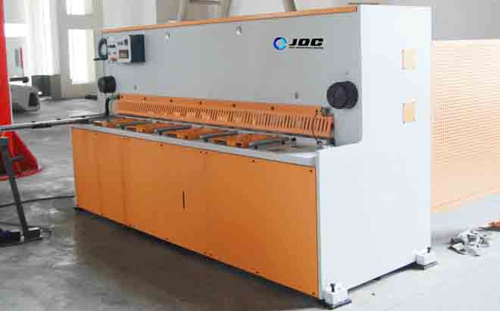  - Fully steel welded construction  - Vibration Traps  - High mechanical strength  - Synchronisation of the bending axles  - High Precision  - Overload protection  - Precise keeping from 3 rolls  - Maximum thickness of cutting black steel (45kg/mm2): 8 mm  - Maximum thickness of cutting stainless steel (60kg/mm2): 4 mm  - Cutting Length: 3100 mm  - Maximum cutting power: 275 kW  - Chamfering angle: 0.5-2degree  - Cycles in minutes: 15-45 min  - Frame Depth: 100 mm  - Oil tank capacity: 290 LT  - Return Speed: 750 mm  - Power: 15 kW  - Length: 3755 mm  - Width: 1848 mm  - Height: 2180 mm  - Weight: 6000 kg
8 | 4-axis CNC Lathe HTSK CNC550T (China)  A high-tech machine that allows fast and economical production of complex lathe-milling parts with large dimensions. The equipment is equipped with two spindle and an additional lower turret with 12 instruments, providing automatic two-way processing of the workpiece in the achievement of maximum processing speed.  Brand: HTSK  Model: CNC 550T  Technical specifications:  - CNC: GSK988TD  - Extremely fast and economical production of complex lathe-milling parts with large dimensions;  - Automatic two-way processing with the help of 2 spindle;  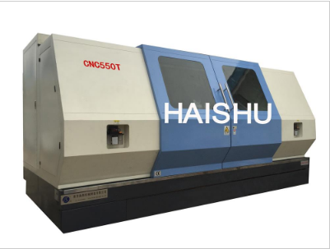  - Two hydraulic jaws;  - Horizontal revolving head with 12 tools for maximum processing speed;  - Additional Y axis;  - Automatic lubrication system;  - Maximum rotation diameter: 550 mm;  - Maximum working length: 750 mm;  - Maximum turning diameter: 500 mm;  - Spindle type: А12;  - Hydraulic Jaws: 2-ф 300 (12 ' ') mm;  - Front spindle bore taper: 1:20;  - Spindle pass: 75 mm;  - Speed of Servo spindled: 0-4000 mm/min;  - Axis X/Z/B Quick moves: 40 000 mm/min;  - CS1, CS2 power of main motors: 15 kW;  - Engine motor on axle C: 5.5 kW;  - Moment by Axis X/Z: 15 Nm;  - Movement on the Y axis: + 55/-55 mm;  - Moment on axis B: 20 N. m;  - Power supply: 380V ± 10%. 50 Hz ± 1 Hz;  - Time to change tool: 1.6 S. (HORIZONTAL12);  - Positioning accuracy: 0.005 "MM;  - Moves on axes X1/X2:350 mm;  - Moves on axes Z1/Z2:1100/1350/1850 mm;  - Axle travel: 1400/1650/2150 mm;  - Speed on axle C: 4000 rpm;  - Biaxality: 0.005 mm;  - Hydraulic Turret: 2-Horizontal 12-station servo power turret;  - Type of tool finger grips: BMT60-ER32;
9 | 5-axis CNC Milling Machine Kinsen VS80160 (China)  Brand: Kinsen  Model: VS80160  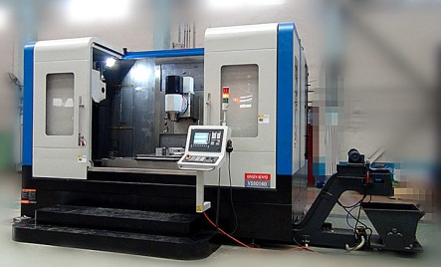  Universal metal processing machine, which can perform simultaneously, and milling and turning operations, thanks to the rotating mass and spindle. The cutter can be operated simultaneously on its 5 axes, which allows the production of complex details – turbines, differentials, tools with complex geometric or organic shape.  Technical specifications:  - Total Installed Capacity: 22.4 kW  - 5-Axis vertical Milling machine for blanks up to 1000-1500kg  - Moves X/Y/Z-1600/800/800  - Handling hard materials for minimum time  - High accuracy in contours and profiles  - Full Auto  - Working table size: 800x1800 mm  - Stroke X/Y/Z: 1600/800/800 mm  - Diameter of NC swivel table axle C: 630 mm  - Rotating mass clamping force: 4000 Nm  - Spindle clamping force: ≥ 2000 Nm  - Maximum mass load: 2000 kg  - Distance from Bayonella to table: 150-950 mm  - Type of Shingle: BT40 ISO  - Spindle diameter: 170 mm  - Spindle rotation angle: ± 110 Degree  - Tool Store Type: BT40 ISO  - Store Capacity: 24 pcs  - Maximum spindle rotation speed: 10 000 r/min  - Spindle stop speed: ≤ 4S seconds  - Spindle power: 15 kW  - Ball-Screw pair: HIWIN  - Spindle: Hesheng  - Ball Bearings: NSK  - Positioning accuracy:  - ≤ X: 0.015 mm  - ≤ Y: 0.015 mm  - ≤ Z: 0.015 mm  - C: 0.002 degree  - B: 0.002 degree  - Repeat accuracy  - ≤ X:0.01 mm  - ≤ Y:0.01 mm  - ≤ Z:0.01 mm  - C:0.0015 Degree  - B:0.0015 Degree  - Parallelism between Axis X and B: ≤ 0.02 degree  - Quick move: ≥ 10000 mm/min  - Milling speed: ≥ 1 to 8000 mm/min  - Weight: 22 ton  - OC "C"  - Rotation angle: ± 180 degree  - Maximum speed: 22 r/min  - Indexing speed: 15 degree/3600  - Repeat accuracy: 4 degree/3600  - Maximum load: 800 kg  - Maximum blank: 800 mm  - Distance between the end of the risers and the table: 220 ~ 1020 mm  - Processing of complex milling details and shapes  - Inclined table for milling at an angle of up to 120 degrees  - Rotating milling head for lateral processing  - Precise fine processing with 10000 spindle turns
10 | CNC Waterjet Cutting Machine TF EMB3015 (China)  Precise, high-performance machine for cutting out blanks for instrumental production, characterized by great thickness and hardness of the material to 56 units.  Brand: TF  Model: EMB3015  Technical specifications:  - Total Installed Capacity: 44.5 kW  - Ball-screw pairs on the X and Y axes  - 17 "LCD display  - Online DNC Mode  - 160GB Hard Drive  - MITSUBISHI AC Servo controls and Motors  - 3000x1500 Workbench  - Cutting depth up to 200 mm  - Auto Abrasive cooling system – 100 LT  - Auto Abrasive cooling system – 170 LT  - Cooling System B: TCO-10A/1D  - Working table  - Stroke Axis X: 3000 mm  - Stroke Y-axis: 1500 mm  - Stroke Axis Z: 150 mm  - Precision with repetition: 0.05 mm  - Speed X, Y: 0.15 mm  - Cutting accuracy: 0.1 mm  - Power supply: 3x220/50 VAC/Hz  - High Pressure pump  - Maximum pressure: 420/60000 MPa/PSI  - Maximum working pressure: 420/60000 MPa/PSI  - Maximum flow: 3.8 lt/min  - Power: 37/50 kW/HP  - Power supply: 3x220/50 VAC/Hz  - CAD/CAM Software  - Communication: Serial PC-> CNC  - Working format: DXF, DWG  - Needle handling: automatic speed delay  - Markup: Option to mark the cutting line  - Cooling System  - Cooling capacity: 125 000/31 500 BTU/kCAL  - Pipe Line Diameter: 2 inch  - Stream: 150 lt/min  - Tank Capacity: 150 LT  - Dimensions: 1350x650x1250 mm  - Weight: 380 kg
11 | 3D Metal Laser Sintering Machine (3D printer) EOS M290 (Germany)  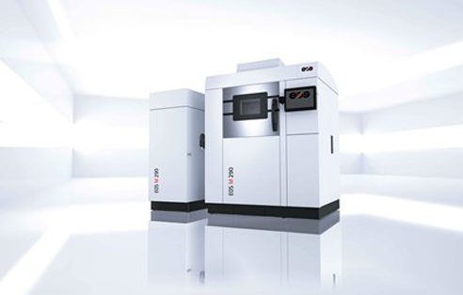  A high-tech machine designed for the production of machine parts from almost any type of metal, using a specially designed metal powder and CNC controlled laser that melts the powder layer by layer until the desired detail is obtained. A 3D printer in this class can produce so-called full density details that can be used not only as prototypes, but also as ready-to-use machine elements.  Brand: EOS  Model: M290  Technical specifications:  - Installed Capacity: Maximum 8.5 kW/Standard 3.2 kW  - Scan speed: Over 7.0 m/s  - Current: 32 A  - Focus Diameter: 100 μm  - Laser type and power: Yb-Fibre laser, 400 W  - Nitrous Generator: Integrated  - Compressed air: 7000 hPA; 20 m3/h  - Dimensions: 2 500 mm x 1 300 mm x 2 190 mm  - Weight: Approx. 1 250 kg  - Maximum working Volume: 250 mm x 250 mm x 325 mm  - Software: EOS RP Tools; EOSTATE, EOSPRINT, Materialise Magics RP  - CAD Interface: STL (with option: Converter for all standard formats)  - Network: Ethernet
 | FREEZING MACHINES AND INSTALLATIONS
12 | Dual Stage Screw Ammonia Compressor Unit - 40°С, model JZ2SLG20/16CS, produced by DALIAN BINGSHAN ENGINEERING & TRADING CO. LTD, China  (1) Screw compressor  Brand: BINGSHAN  Model: JZ2SLG20/16CS  (2) Ammonia pump  Brand: BINGSHAN  Model: 50P-40  Technical specifications:  - Screw compressor JZ2SLG20/16CS  - LCD Touch Display  - Online mode  - Evaporation Temperature – 40  - No-step control 10-100%  - Frequency regulator of revolutions-30-100%  - SMC Control Dashboard  - Screw Compressor:  - Capacity adjustment: 10-100%  - Refrigeration power at – 42 °c: 205 kW  - Refrigeration power at 0 °c: 586 kW  - Motor: 3x380V @ 50Hz 2960 r/min, 185 kW  - Power consumption: 135.8 kW  - Dimensions: L 3780 x W 1495 x H 2310mm  - OIL COOLER: water-cooled; 25 m3/h  - Oil pump: hydraulic; 150 m3/h  - SMC: 17 "color display, 6 pieces of PLC Siemens S 400, Siemens engine speed regulator;  - Automation for control of the compressor and the oil cooler: Solenoid valve Danfoss, Hansen sensor valve, expansion valve Danfoss;  - Suction pipe: DN 150  - Unloading pipe: DN 65  - OIL COOLER Inlet pipe: DN 32  - OIL COOLER output pipe: DN 65  - Compressor Weight: 5500 kg  - Ammonia pump 50P-40  - Maximum Capacity: 12.5 m3/h  - Operating temperature: – 40 °c to + 40 °c  - Liquid gas application: R 717 (NH), R 22, CO, R 134a, R 404a, R11, R12, Baysilone (M3, M5), methanol, silicon oil KT3, syltherm, lithium bromide.  - Ammonia Flow: 12.5 m3/h  - Head: 43 m  - Engine speed: 2850 rpm  - Operating Temperature: – 40 to + 40 °c  - Engine power: 4 kW  - NPSHr: 3.5 m  - Operating pressure: 1.6 MPa  - Dimensions HxLxW: 700x370x370 mm
13 | Single Stage Screw Ammonia Compressor Unit - 0°С, model JZ2LG12.5, produced by DALIAN BINGSHAN ENGINEERING & TRADING CO. LTD, China  (1) Screw compressor  Brand: BINGSHAN  Model: JZ2LG12.5  (2) Ammonia pump  Brand: BINGSHAN  Model: 50P-40  Technical specifications:  - Screw compressor JZ2LG 12.5  - LCD Touch Display  - Online mode  - Evaporation temperature 0 ° С  - No-step control 10-100%  - Frequency regulator of revolutions-30-100%  - SMC Control Dashboard  • Screw compressor:  - capacity adjustment: 10-100%  - refrigeration power at 0 °c: 272 kW  - Motor: 3x380V @ 50Hz 2960 r/min, 65 kW  - Power consumption: 48.5 kW  - Dimensions: L 2690 x W 1100 x H 1795 mm  - OIL COOLER: water-cooled; 25 m3/h  - Oil pump: hydraulic; 150 m3/h  - SMC: 17 "color display, 6 pieces of PLC Siemens S 400, Siemens engine speed regulator;  - Automation for control of the compressor and the oil cooler: Solenoid valve Danfoss, Hansen sensor valve, expansion valve Danfoss;  - Suction pipe: DN 150  - Unloading pipe: DN 65  - Inlet pipe of the oil cooler: DN 20  - OIL COOLER output pipe: DN 32  - Compressor Weight: 2243 kg  - Ammonia pump 50P-40  - Maximum Capacity: 12.5 m3/h  - Operating Temperature: – 40 °c to + 40 °c  - Liquid Gas Application: R 717 (NH), R 22, CO, R 134a, R 404a, R11, R12, Baysilone (M3, M5), methanol, silicon oil KT3, syltherm, lithium bromide.  - Ammonia Flow: 12.5 m3/h  - Head: 43 m  - engine speed: 2850 rpm  - Operating Temperature: – 40 to + 40 °c  - engine power: 4 kW  - NPSHr: 3.5 m  - Working pressure: 1.6 MPa  - Dimensions HxLxW: 700x370x370 mm
14 | Single Stage Screw Ammonia Compressor Unit - 12°С, model JJZ2LG16, produced by DALIAN BINGSHAN ENGINEERING & TRADING CO. LTD, China  (1) Screw compressor  Brand: BINGSHAN  Model: JJZ2LG16  (2) Ammonia pump  Brand: BINGSHAN  Model: 50P-40  Technical specifications:  - Screw compressor JJZ2LG16  - LCD Touch Display  - Online mode  - Evaporation temperature-12 ° с  - No-step control 10-100%  - Frequency regulator of revolutions-30-100%  - SMC Control Dashboard  - Screw compressor:  - Capacity adjustment: 10-100%  - Refrigeration power at – 12 °c: 375 kW  - Motor: 3x380V @ 50Hz 2960 r/min, 125 kW  - Power consumption: 99.7 kW  - Dimensions: L 3500 x W 1080 x H 1860 mm  - OIL COOLER: water-cooled; 25 m3/h  - Oil pump: hydraulic; 150 m3/h  - SMC: 17 "color display, 6 pieces of PLC Siemens S 400, Siemens engine speed regulator;  - Automation for control of the compressor and the oil cooler: Solenoid valve Danfoss, Hansen sensor valve, expansion valve Danfoss;  - Suction pipe: DN 100  - Unloading pipe: DN 80  - OIL COOLER Inlet pipe: DN 25  - OIL COOLER output pipe: DN 65  - Compressor Weight: 2600 kg  - Ammonia pump 50P-40  - Maximum Capacity: 12.5 m3/h  - Operating temperature: – 40 °c to + 40 °c  - Liquid gas application: R 717 (NH), R 22, CO, R 134a, R 404a, R11, R12, Baysilone (M3, M5), methanol, silicon oil KT3, syltherm, lithium bromide.  - Ammonia Flow: 12.5 m3/h  - Head: 43 m  - Engine speed: 2850 rpm  - Operating Temperature: – 40 to + 40 °c  - Engine power: 4 kW  - NPSHr: 3.5 m  - Operating pressure: 1.6 MPa  - Dimensions HxLxW: 700x370x370 mm
15 | BAC Ammonia Evaporative Condenser, model CXV-387GP, produced by DALIAN BINGSHAN ENGINEERING & TRADING CO. LTD, China  Evaporative condenser with air-water cooling of the refrigerant designed to remove excess heat from the cooling system.  Brand: BINGSHAN  Model: CXV-387 GP  Technical specifications:  - Consists of a two-section body made of hot zinc plated steel with coating 400 g/m2  - In the lower section are located evaporation combs also made of hot galvanized steel coated 400 g/m2. Through these combs passes the refrigerant which must be cooled. In the upper section of the body are located the Bodysprinkler system and fans by which the heat of the refrigerant is withdrawn and it can be returned to the cooling system again.  - Evaporation capacity 1666 KW  - Water dispersion System: 30 lt/s  - Spray Blower: 600 mm  - Bottom section of condenser: 3000x5500x7600 mm  - Top section of the condenser: 3000x1150x7600 mm  - Maximum working pressure: 23 Bar  - Maximum coolant temperature: + 120 °c  - Minimum coolant temperature:-20 °c  - PH of water: 7-9  - Electric Power: 22 kW  - Evaporative power: 1666 kW  - Weight: 8400 kg
16 | Spiral Freezer, model FSH 900  Spiral Freezer to freeze products.  Brand: IFS  Model: FSH 900  Technical specifications:  - 17 ' colour display, RS-232 port  - Self-supporting stainless strip  - Automatic defrosting of the evaporator  - Automatic installation for washing and disinfection  - Remote Control Panel  - Operating Parameters:  - Ribbon width: 920 mm  - Maximum diameter above the subwoofer: 610 mm  - Distance between floors: 80 mm  - Ribbon Length: 400 m  - Number of rows: 25 PCE  - Maximum product height: 60 mm  - Total external dimensions of the construction: 9000/6000/4500 mm  - Speed: Adjustable; 25 -140 min  - Submission  - Product Feed Height: 820 mm  - Product Output Height: 3800 mm  - Freezing capacity up to – 18 C: 2 t/h  - Power  - Refrigeration power of product: 245 kW  - Refrigeration power to the evaporator: 265 kW  - Suction Temperature:-40 C  - Air temperature:-35 C  - Engine power: 15 kW  - Internal filament diameter: 3000 mm  - Maximum diameter of the strip: 5400 mm  - Fans power: 32 kW  - Total Installed Capacity: 47 kW  - Thickness of the polyurethane panels minimum: 200 mm  - Evaporators of stainless steel pipes with pressed stainless plates and a device for automatic defrosting with air: 4000/2500/1500 (L/H/W)  - Electric Switchboard: Electrical control Panel with software in Bulgarian language, Siemens PLC S 7 300, protection degree IP 67, allowing full pouring with water, stainless steel housing  - Control of rotational speed  - Alarm for errors and accidents  - Temperature Calibration  - Hour counter  - Histogram of products for 6 months  - Omron Drum Rotation frequency regulator  - Internet Modem for remote diagnostics  - Remote Control Panel Siemens  - Machine Weight: 15000 kg

The technical passports of the machines are available upon request.

